# **Practical 1**

## **A.Write a program for obtaining descriptive statistics of data**.

**Step 1**: Open your data in excel

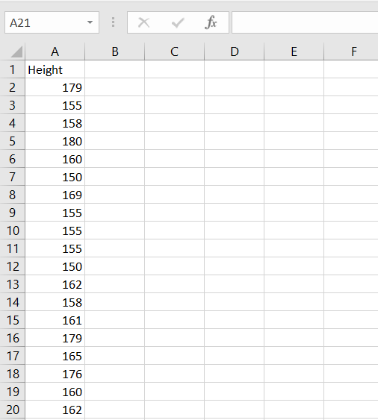

**Step 2:** From the Data Tool in the ribbon choose Data Analysis.

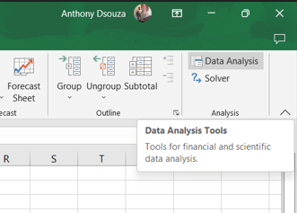

**Step 3**: Select the option of descriptive statistics

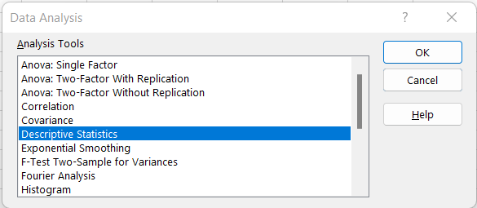

**Step 4:** Select an input range, output range, and check summary statistics and confidence level.

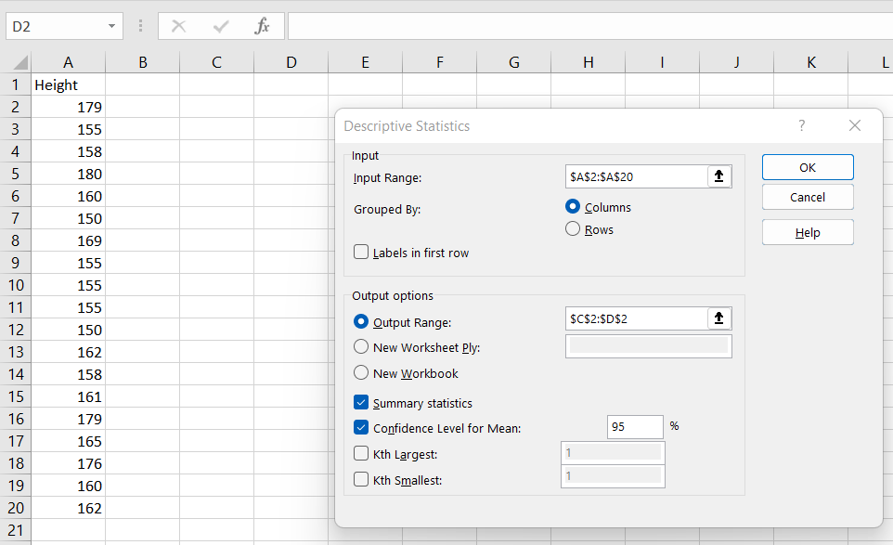

**Step 5:** The output may appear as follows.

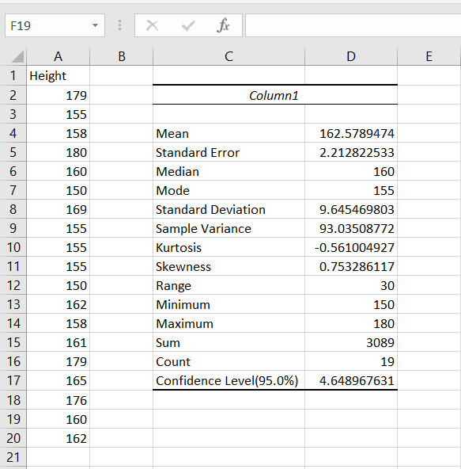

**Conclusion:** we have successfully obtained the descriptive statistics in data.

## **B.Import data from different data sources (from Excel, csv, mysql, sql server, oracle to R /Python /Excel )**

**Code:**

### **1 - SQLite3**

import sqlite3 as sq

import pandas as pd

############################################

Base='C:/VKHCG'

sDatabaseName=Base + '/01-Vermeulen/04-Transform//SQLite/vermeulen.db'

conn = sq.connect(sDatabaseName)

############################################

sFileName='C:/VKHCG/01-Vermeulen/01-Retrieve/01-EDS/02-Python/Retrieve_IP_DATA.csv'

print('Loading :',sFileName)

IP_DATA_ALL_FIX=pd.read_csv(sFileName,header=0,low_memory=False)

IP_DATA_ALL_FIX.index.names = ['RowIDCSV']

sTable='IP_DATA_ALL'

print('Storing :',sDatabaseName,' Table:',sTable)

IP_DATA_ALL_FIX.to_sql(sTable, conn, if_exists="replace")

print('Loading :',sDatabaseName,' Table:',sTable)

TestData=pd.read_sql_query("select * from IP_DATA_ALL;", conn)

print('## Data Values')

print(TestData)

print('## Data Profile')

print('Rows :',TestData.shape[0])

print('Columns :',TestData.shape[1])

print('Successful')1

**Output:**

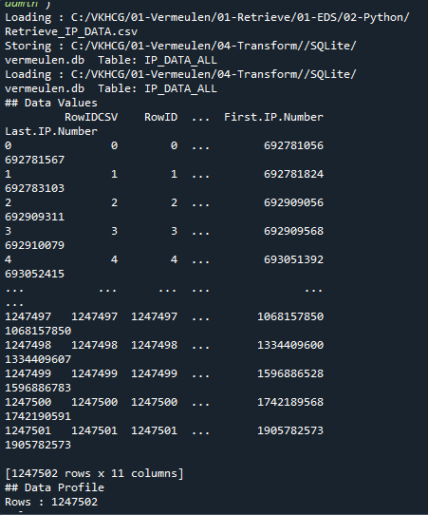

### 2 - Excel

import os

import pandas as pd

Base='C:/VKHCG'

sFileDir=Base + '/01-Vermeulen/01-Retrieve/01-EDS/02-Python'

CurrencyRawData = pd.read_excel('C:/VKHCG/01-Vermeulen/00-RawData/Country_Currency.xlsx')

sColumns = ['Country or territory', 'Currency', 'ISO-4217']

CurrencyData = CurrencyRawData[sColumns]

CurrencyData.rename(columns={'Country or territory': 'Country', 'ISO-4217':

'CurrencyCode'}, inplace=True)

CurrencyData.dropna(subset=['Currency'],inplace=True)

CurrencyData['Country'] = CurrencyData['Country'].map(lambda x: x.strip())

CurrencyData['Currency'] = CurrencyData['Currency'].map(lambda x:

x.strip())

CurrencyData['CurrencyCode'] = CurrencyData['CurrencyCode'].map(lambda x:

x.strip())

print(CurrencyData)

print('~~~~~~ Data from Excel Sheet Retrived Successfully ~~~~~~~')

sFileName=sFileDir + '/Retrieve-Country-Currency.csv'

CurrencyData.to_csv(sFileName, index = False)

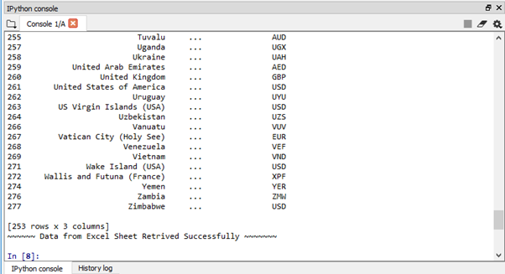

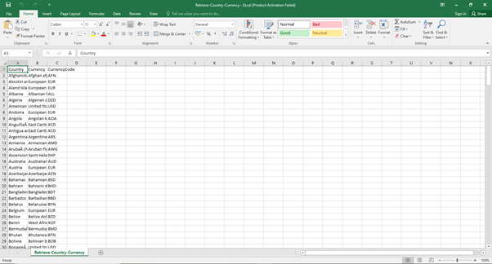

**Conclusion:** we have successfully imported data from SQLite3 and Excel in this program.

# **Practical 2**

## **A.Design a survey form for a given case study, collect the primary data and analyse it.**

**Step 1:** In order to make a survey we used Google forms. Our case study’s aim was to find out which age group did Shopping in festive seasons.



**Step 2**: The questions and options entered were as follows.

Q1.Which group do you belong to?

(a)10-20 (b)21-30 (c)31-40 (d)41-50 (e)51 Above

Q2.What is your Gender?

(a)Male (b)Female

Q3.What is your Occupation?

(a)Business (b)Student (c)Employee (d)Retired (e)Self Employed (f)Household

Q4.What's your Monthly Income?

(a)10,000 - 20,000 (b)21,000 - 30,000 (c)31,000 - 40,000 (d)41,000 and above (e)N/A

Q5.How often do you shop?

(a)Monthly (b)Occasionaly (c)Festive Seasons (d)Rarely

Q6.Purpose of Shopping?

(a)Personal Use (b)Gifting

Q7.Where do you get to know about the festive sales?

(a)Newspaper (b)Advertisement (c)WhatsApp (d)Through a person

Q8.How would you rate your overall shopping experience during festive season?

(a)Excellent (b)Good (c)Average (d)Poor

**Step 3 :**Google forms tool was chosen because analysis becomes easier on Google forms.

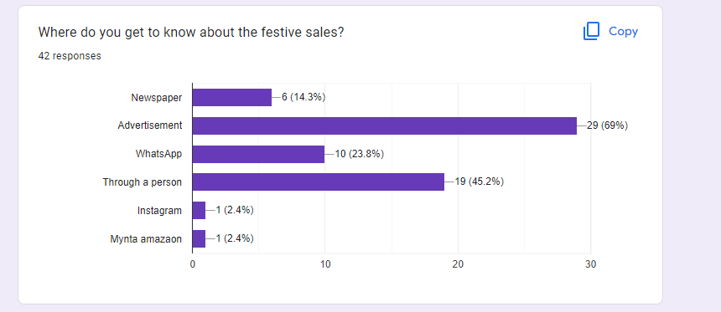

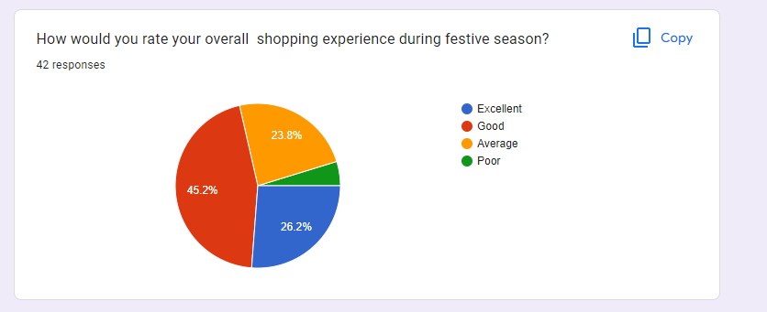

**Conclusion:** we have successfully made the survey form for the given case study.

## **B.Perform analysis of given secondary data.**

Step 1: Open Data in excel

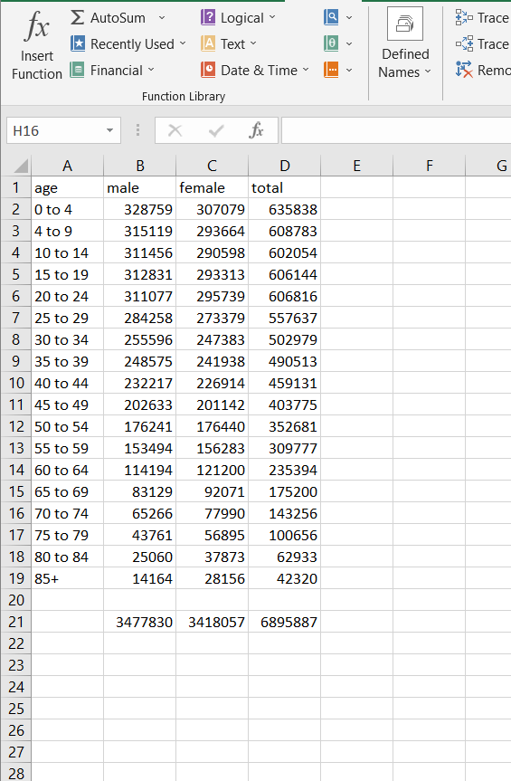

**Step 2:** Calculate the total sum of each column. Select the cell for Sum→ add formula SUM in formula bar→ select the range.



**Step 3:** Calculate the percentage of male in cell E. Use formula -1*100*B2/$D$21

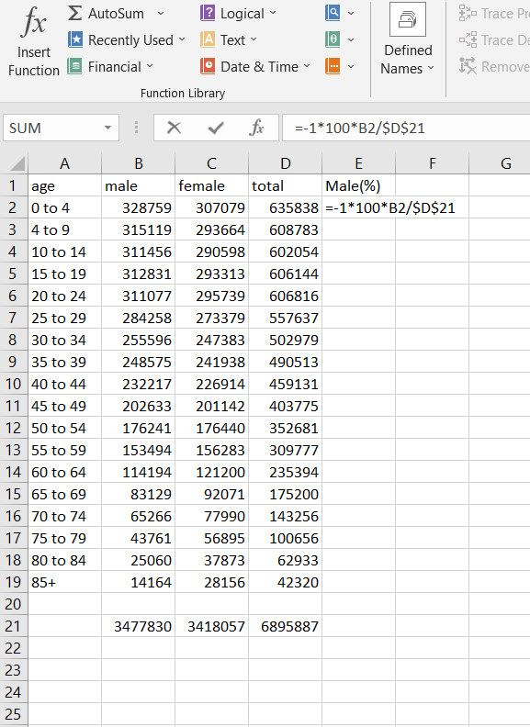

**Step 4:** Calculate the percentage female in cell F. Use formula 100*C2/$D$21

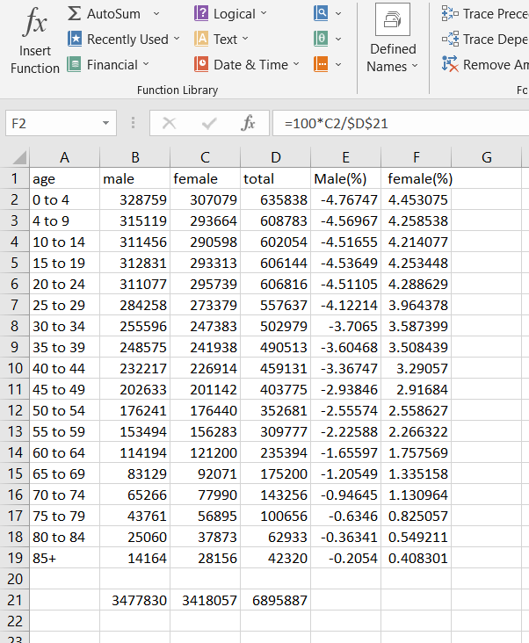

**Step 5:** The modified data may seem as follows.

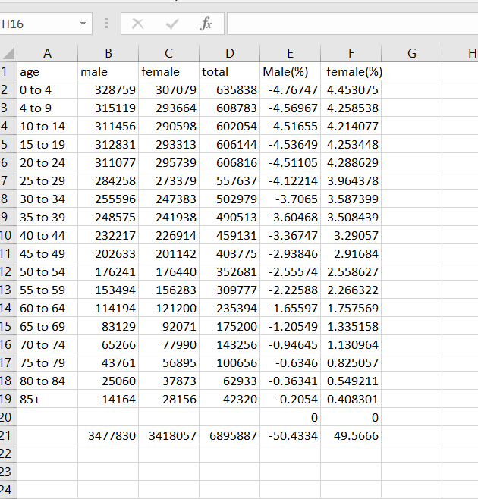

**Step 6:** For analysis go to Insert → Bar → 2D

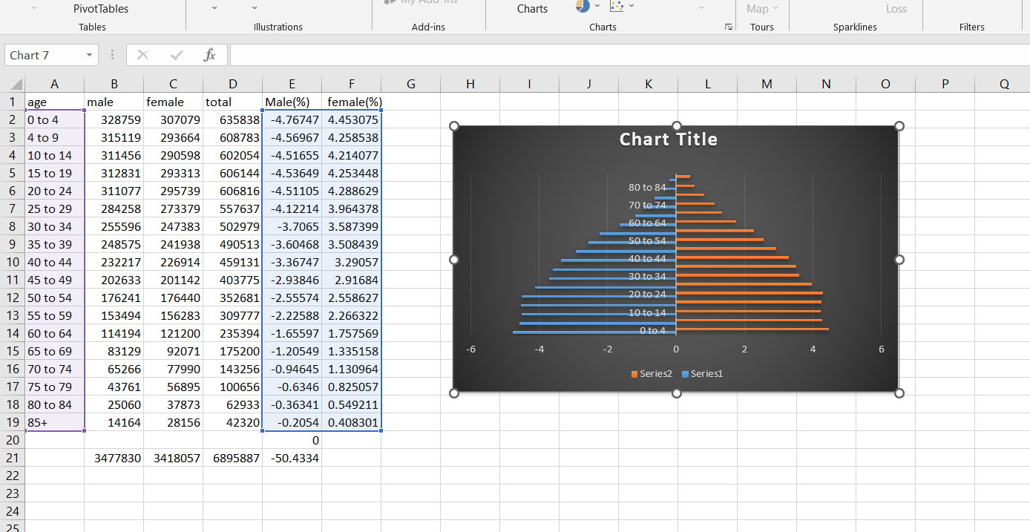

**Step 7** :Drag the data and set the graph for analysis.

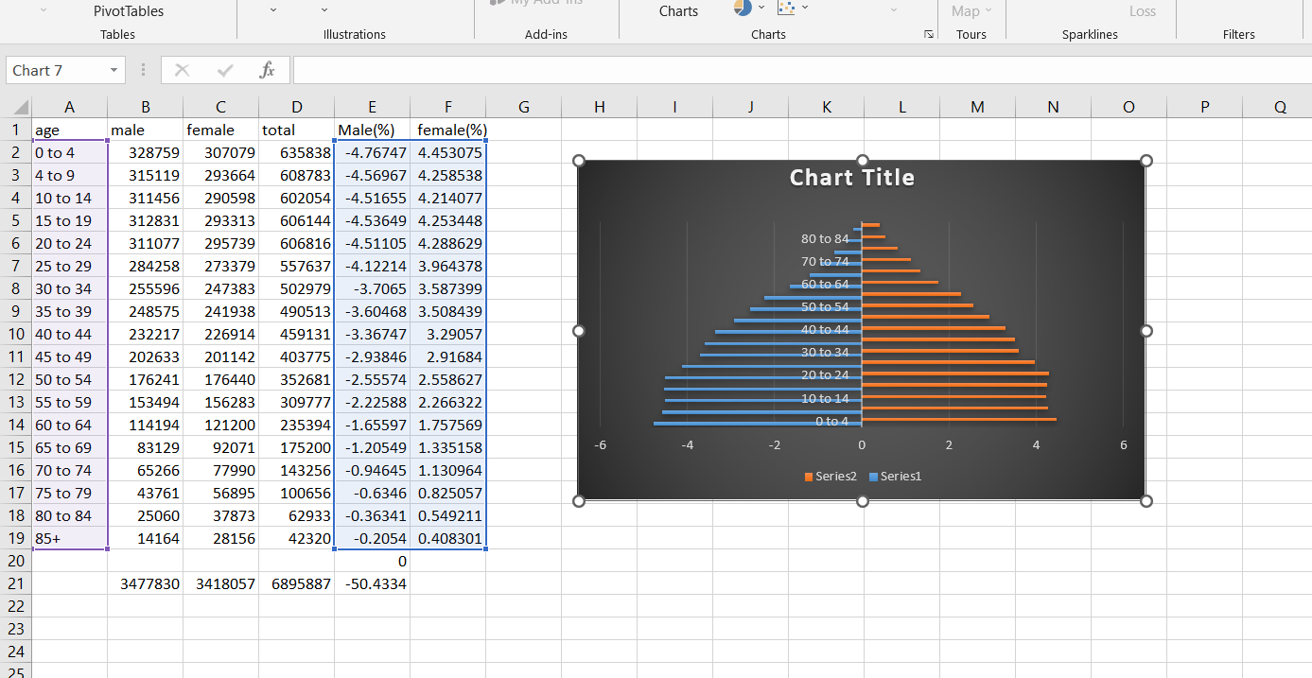

**Conclusion:** we have successfully performed the analysis for the given secondary data.

# **Practical 3**

## **A.Perform testing of hypothesis using one sample t-test.**

**Code:**

from scipy.stats import ttest_1samp

import numpy as np

ages=np.genfromtxt('H:/ages.csv')

print(ages)

ages_mean=np.mean(ages)

print(ages_mean)

tset,pval=ttest_1samp(ages,30)

print('p-values-',pval)

if pval<0.05:#alpha value is 0.05

print("we are rejecting null hypothesis")

else:

print("we are accepeting null hypothesis")

**Output:**

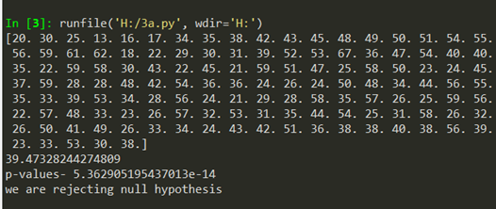

**Conclusion:** we have successfully performed testing of hypothesis using one sample t-test.

## **B.Write a program for t-test comparing two means for independent samples.**

**Step 1:** Calculate the mean of the samples (Total /Count)

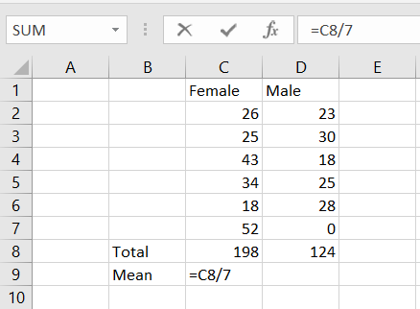 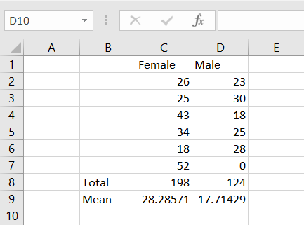

**Step 2:** Calculate the SD of samples STDEV(range)

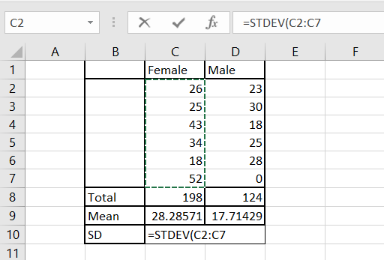

**Step 3:** Calculate the t-test

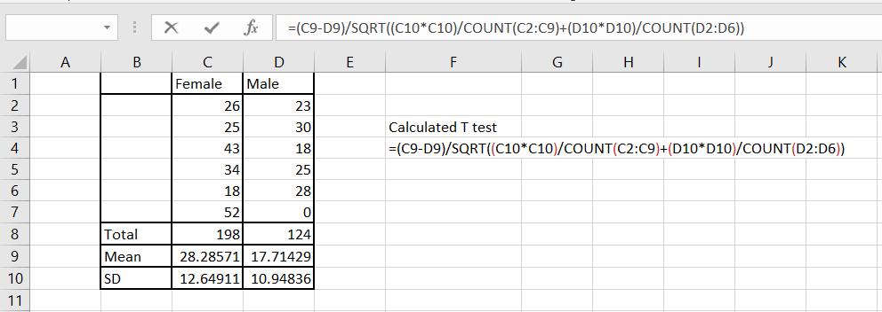

**Step 4:** Apply t-test paired two Samples for Means.

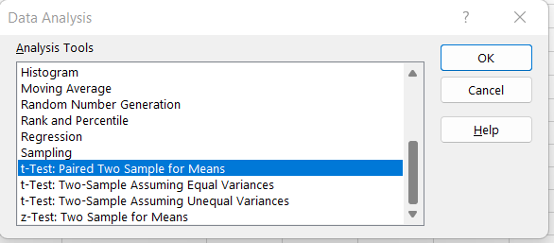

**Step 5:** Apply input Range and Output range.

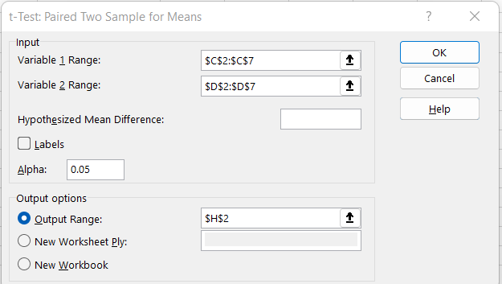

**Step 6:** Hence we reject null hypothesis.

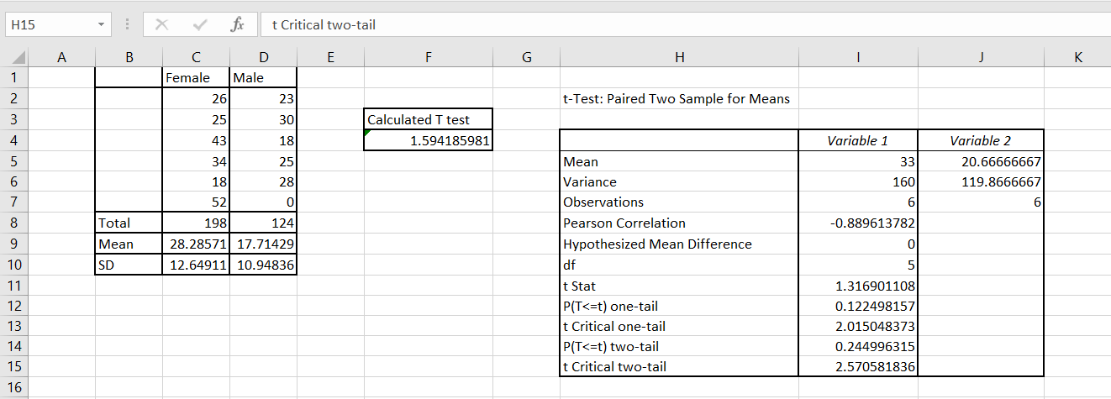

**Conclusion:** we have successfully compared the two means of independent samples for a t-test.

## **C.Perform testing of Hypothesis using paired t-test.**

**Step 1:** Load the Data

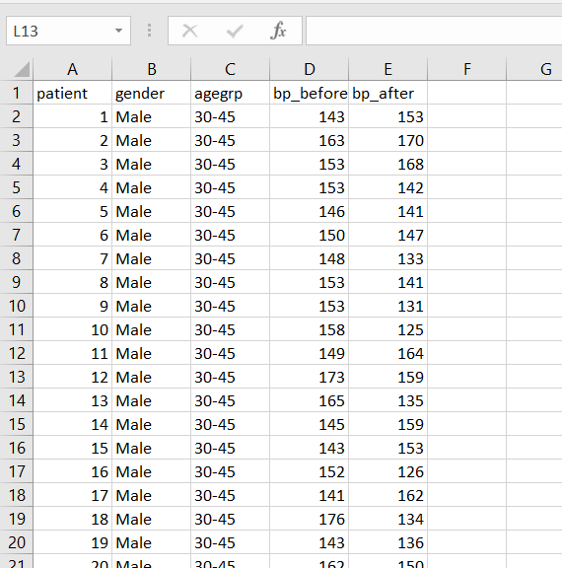

**Step 2:** Data -> Data Analysis -> t-test between samples for means.

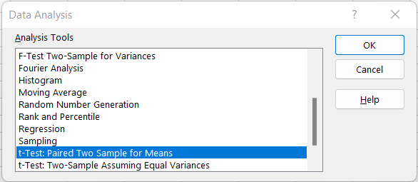

**Step 3:** Choose the Input and Output range.

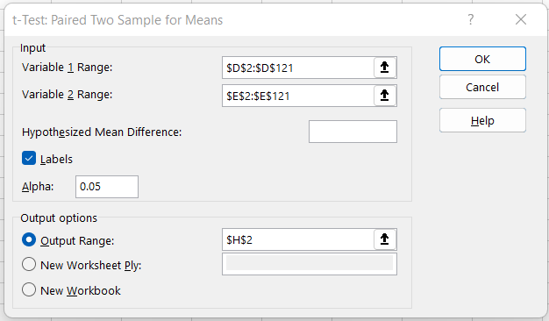

**Step 4:** Since the samples Means of the Data samples are not equal we reject the null hypothesis that they might be equal.

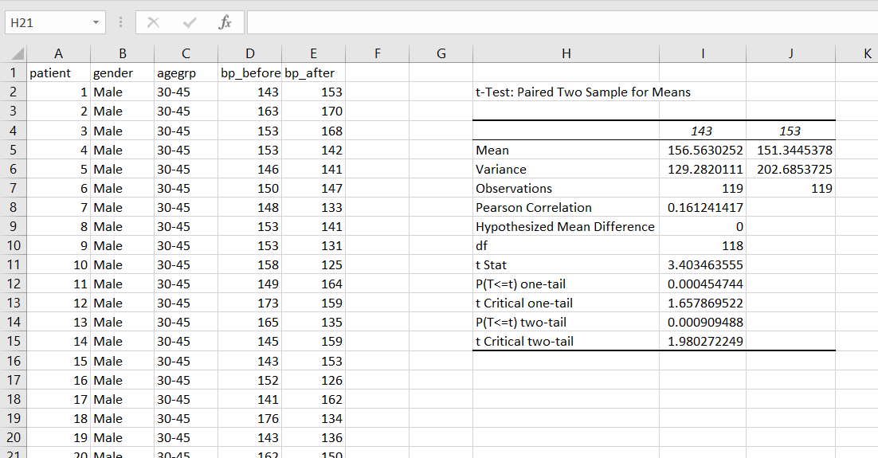

**Conclusion:** we have performed the testing of hypothesis using paired t-test.

# **Practical 4**

## **A.Perform testing of hypothesis using chi-squared goodness-of-fit test.**

**Step 1:** Load the data.

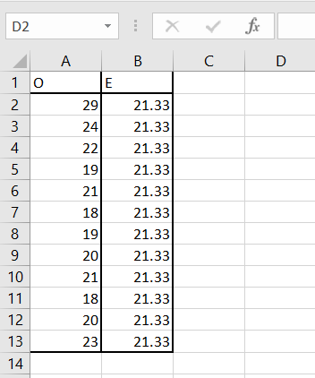

**Step 2:** Type CHITEST and select Actual(observed value range) and Expected value range.

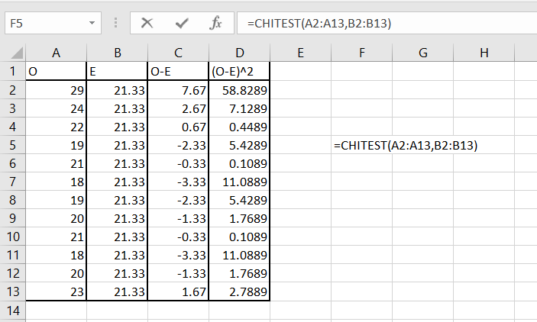

**Step 3:** This calculated value is less than table value which is 19.68. Hence we accept null hypothesis.

i.e 0.932663 < 19.68. H0 accepted.

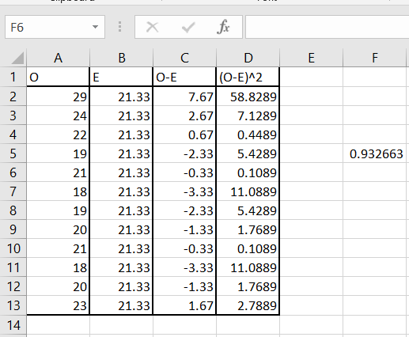

## 

## 

## **B.Perform testing of hypothesis using chi-squared test of independence.**

**Step 1:** Load the data

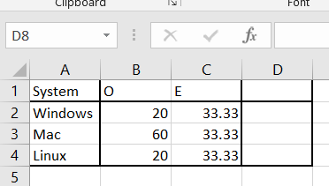

**Step 2:** Calculate the value of (O-E)^2 /E

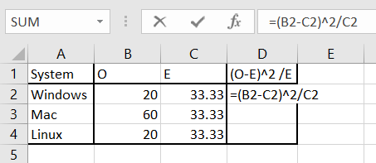

**Step 3:** Calculate Chi square at 5% confidence and degree of freedom n-1=2(in our case)

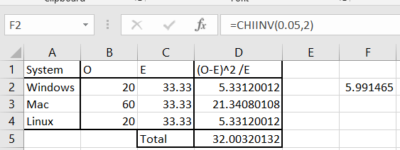

**Conclusion:** we have successfully performed the chi-squared test.

# 

# 

# 

# **Practical 5**

## **Perform testing of hypothesis using Z-test.**

**Step 1:** Load the data

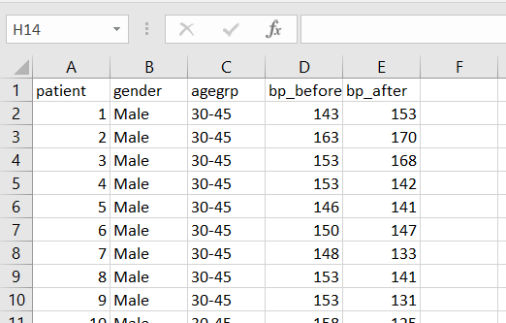

**Step 2:** To apply Z test we need a sample size over 30. Here our sample size is 120 data points , so to apply Z-test go to Data -> Data analysis.



**Step 3:** Select Z-Test: Two Sample for means.

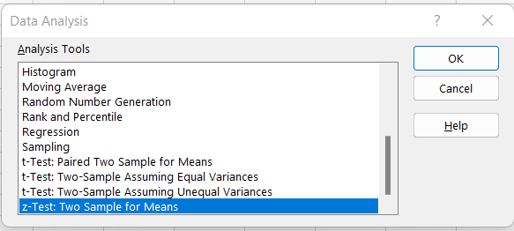

**Step 4:** Varience can be calculated using VAR.S (range)

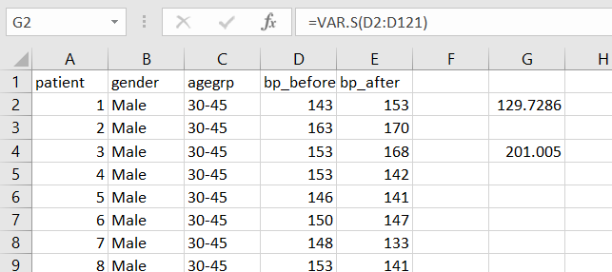

**Step 5:** Set the Variable 1 and 2 range.

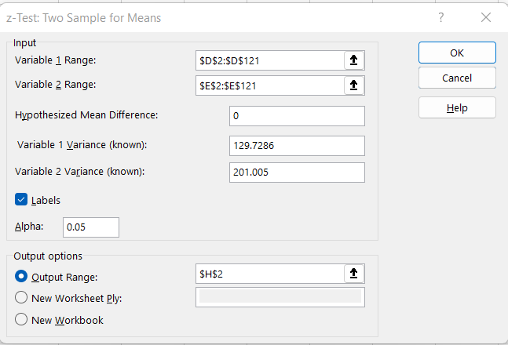

**Step 6**: Output

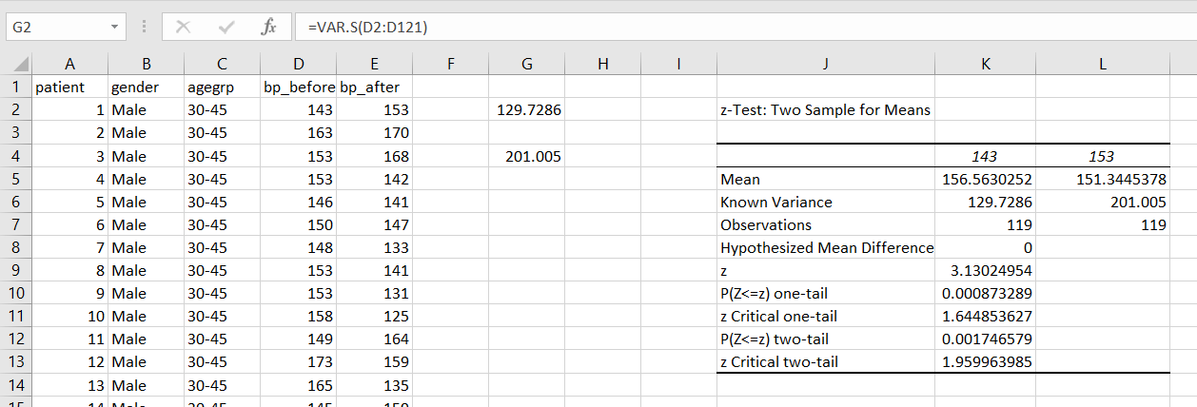

**Conclusion:** we have successfully performed the Z-Test hypothesis.

# **Practical 6**

## **A.Perform testing of hypothesis using One-way ANOVA.**

**Step 1:** Load the data

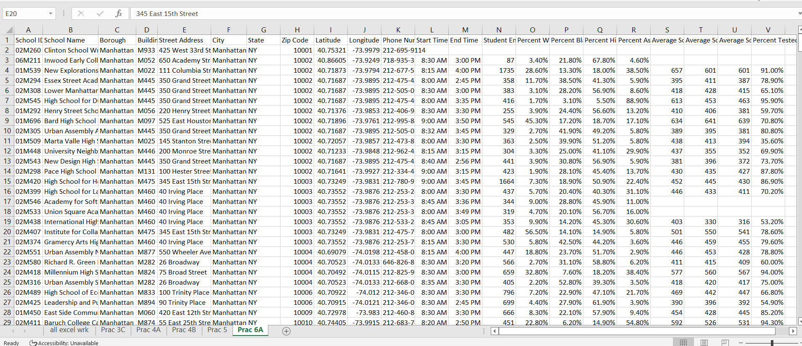

**Step 2:** To Calculate Single factor(one-way) anova we use cells S,T,U .

Data -> Data Analysis.



**Step 3:** Select Anova: Single Factor

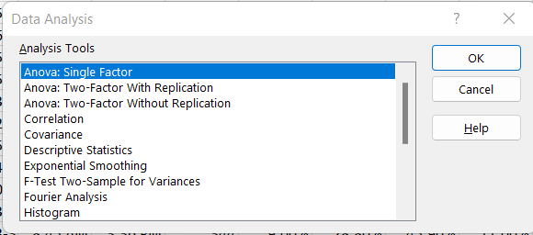

**Step 4:** Select the cells of S-T-U for input range

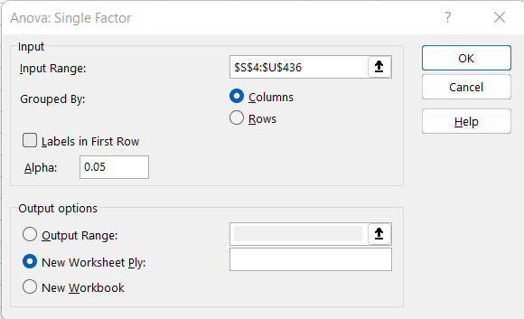

**Step 5**: Output

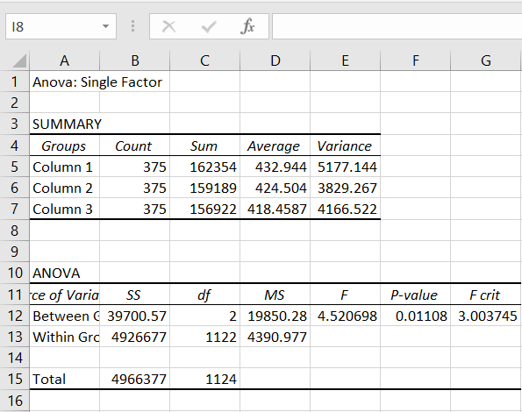

**Conclusion:** we have successfully performed one-way ANOVA.

## 

## 

## **B.Perform testing of hypothesis using Two-way ANOVA.**

**Step 1:** Load the data.

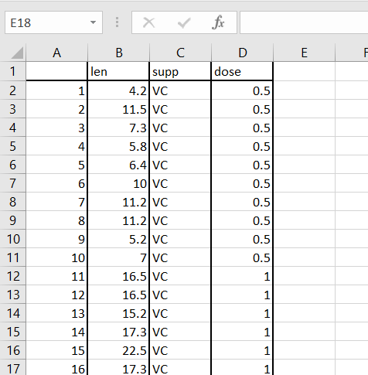

**Step 2:** Data -> Data Analysis



**Step 3**: Select Anova: Two Factor with Replication

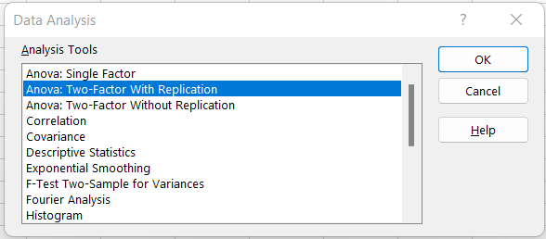

**Step 4**: Select input and output range

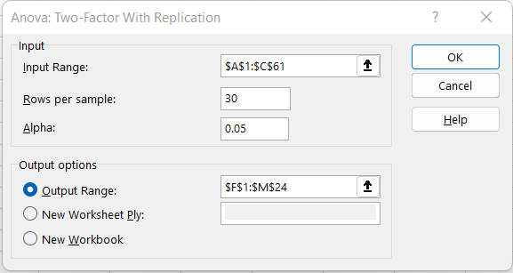

**Step 5**: Output

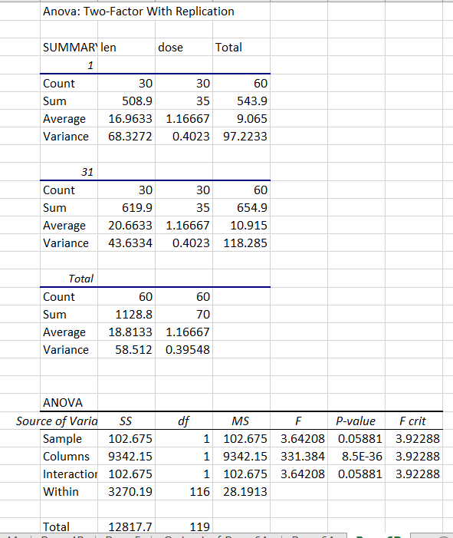

**Conclusion:** we have successfully performed two way ANOVA.

## **C.Perform testing of hypothesis using MANOVA.**

**Step 1:** Load the Data.

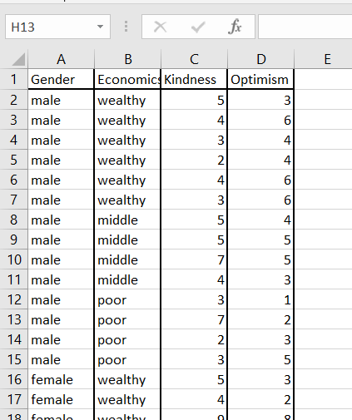

**Step 2:** Install Add-in in excel.

Select **File -> Help | Options -> Add-Ins** and click on the **Go** button at the bottom of the window.

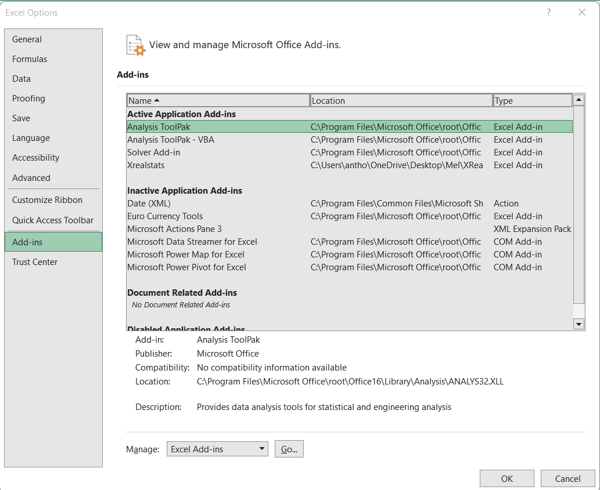

**Step 3:** Click on browse and select XrealStats file. Check the following check boxes.

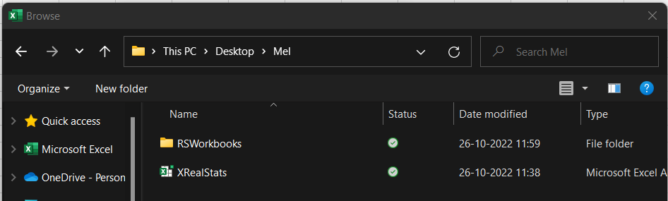

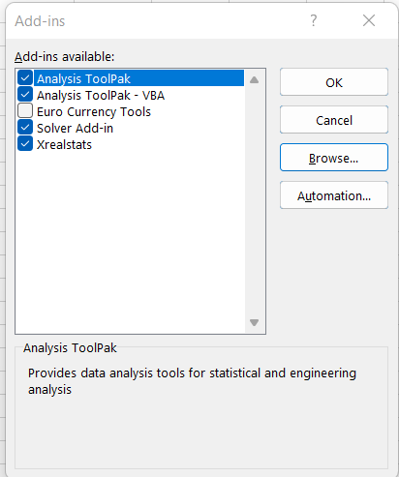

**Step 4**: Once loaded , CTRL+M to perform MANOVA. Click Multivar -> Manova: two factor -> OK.

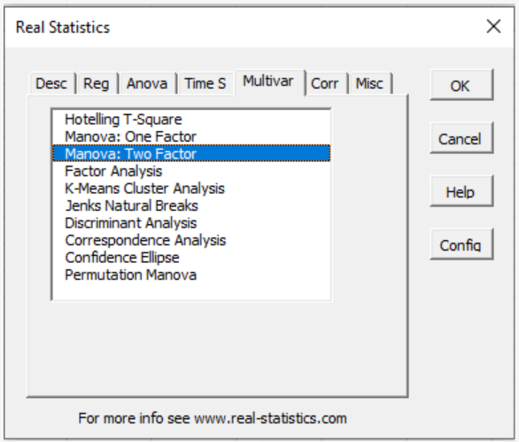

**Step 5**: Select the data excluding column names. Select a cell for output

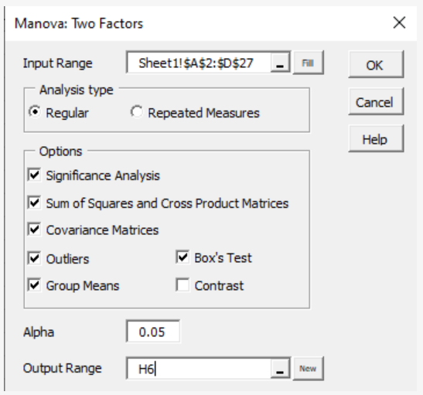

**Step 6**: Output

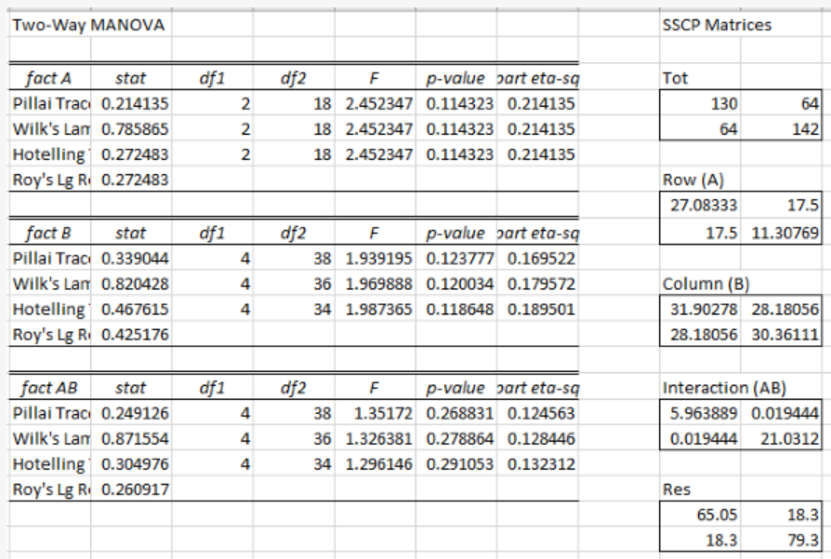

**Conclusion:** we have successfully performed MANOVA.

# **Practical 7**

## **A.Perform the Random sampling for the given data and analyse it.**

**Step 1**: Load the data.

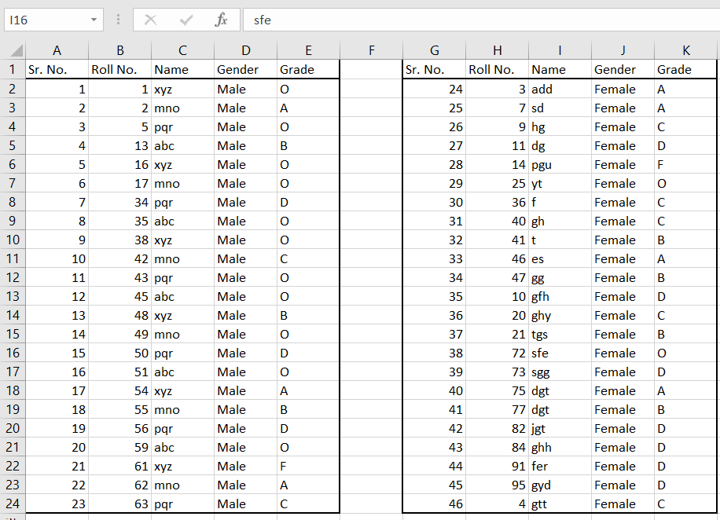

**Step 2:** Set Cell O1= Male and Cell P2= Female

To generate a random sample for male students from given population go to Cell O1 and type =INDEX(E$2:E$62,RANK(B2,B$2:B$62))

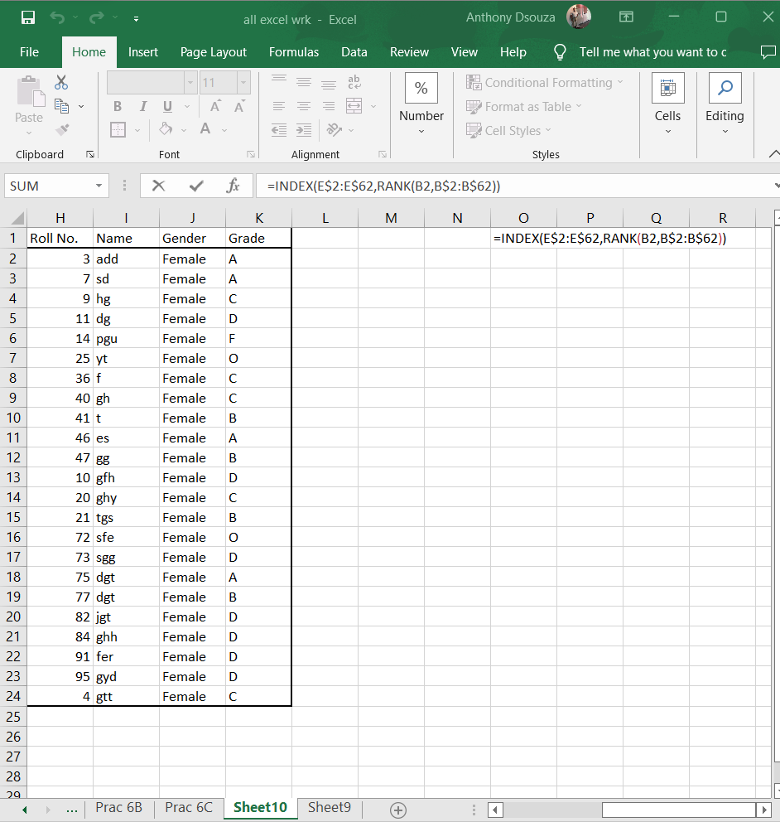

**Step 3:** Repeat the step to perform random sampling on Female data.

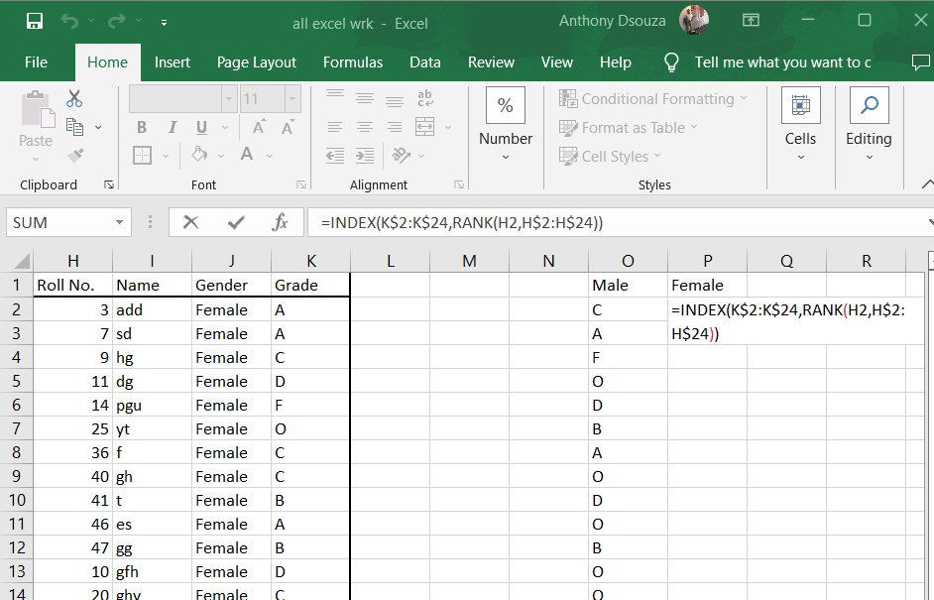

**Step 4:** Output

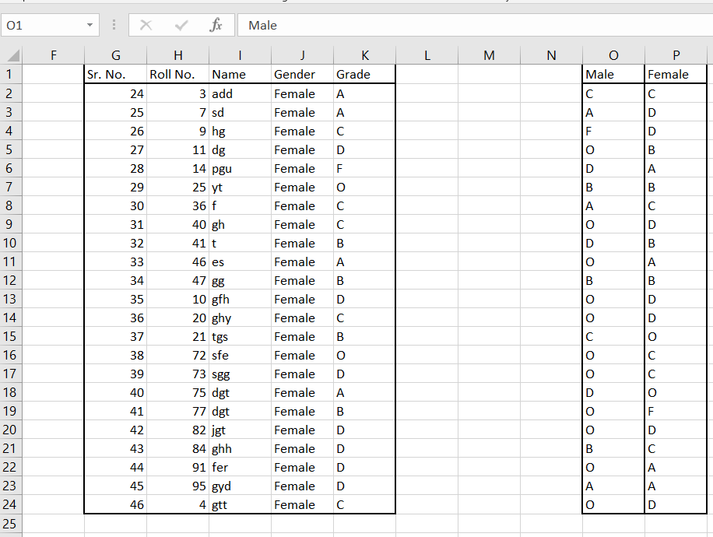

**Conclusion:** we have successfully performed Random sampling and analyze it.

## **B.Perform the Stratified sampling for the given data and analyse it**

**Step 1:** Load the data.

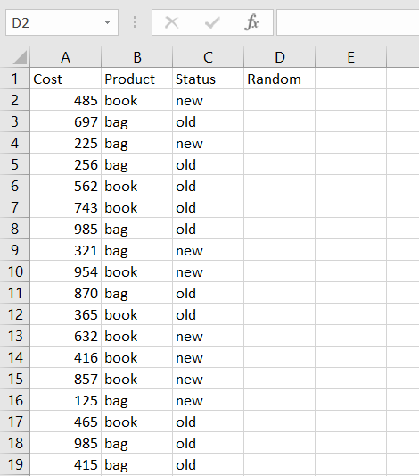

**Step 2**: Assign Random values using RAND() function.

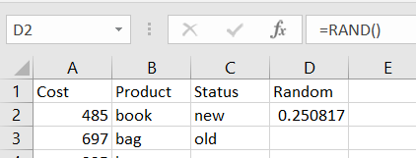

**Step 3**: Copy the entire column D and paste only values

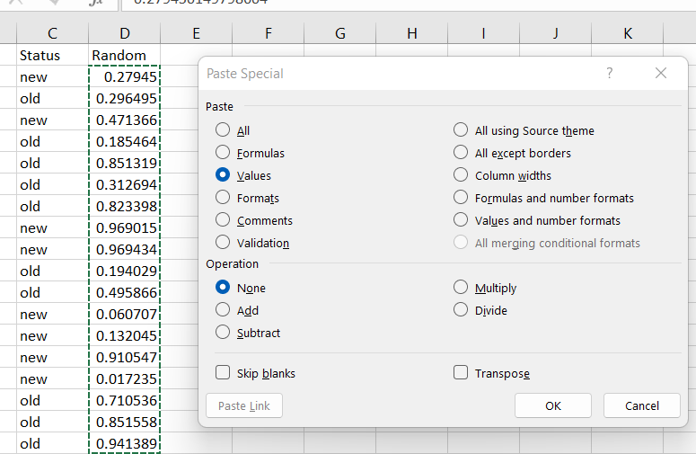

**Step 4:** To perform stratified sampling and obtain data where we get 2 new books cost, 2 old books cost, 2 new bags cost, 2 old bags cost. Select the data and click on sort.

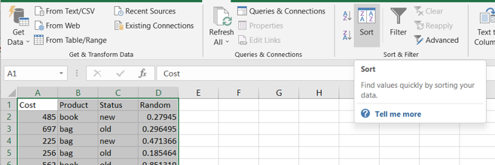

**Step 5**: Sort the data by product , status and random.

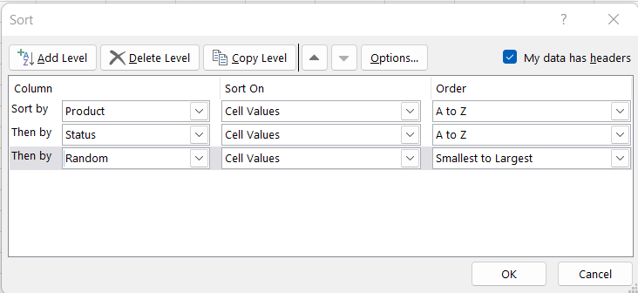

Step 6: the output obtained will be as follows.

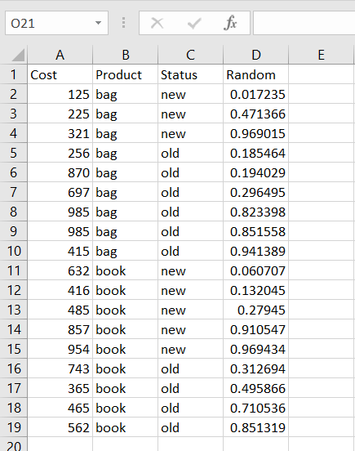

**Conclusion:** we have successfully performed stratified sampling and analyse it.

# **Practical 8**

**Write a program for computing different correlation**

## **A.Positive Correlation.**

**Code:** import matplotlib

import numpy as np

import matplotlib.pyplot as plt

np.random.seed(1)

# 1000 random integers between 0 and 50

x = np.random.randint(0, 50, 1000)

# Positive Correlation with some noise

y = x + np.random.normal(0, 10, 1000)

np.corrcoef(x, y)

matplotlib.style.use('ggplot')

plt.scatter(x, y)

plt.show()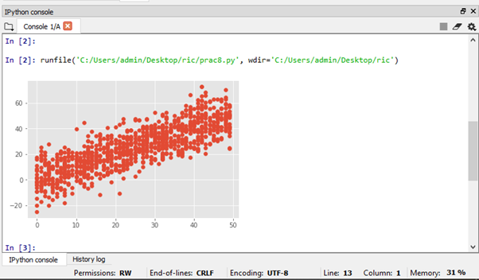

**Output:**

## 

## 

**Conclusion:** we have successfully computed positive correlation.

## **B.Negative Correlation.**

**Code:**

import matplotlib

import numpy as np

import matplotlib.pyplot as plt

np.random.seed(1)

# 1000 random integers between 0 and 50

x = np.random.randint(0, 50, 1000)

# Negative Correlation with some noise

y = 100 - x + np.random.normal(0, 5, 1000)

np.corrcoef(x, y)

plt.scatter(x, y)

plt.show()

**Output:**

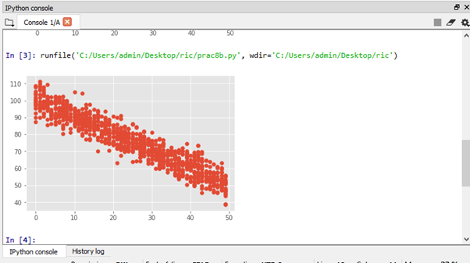

**Conclusion:** we have successfully computed negative correlation.

## **C.No/Weak Correlation.**

**Code:**

import numpy as np

import matplotlib.pyplot as plt

np.random.seed(1)

x = np.random.randint(0, 50, 1000)

y = np.random.randint(0, 50, 1000)

np.corrcoef(x, y)

plt.scatter(x, y)

plt.show()

**Output:**

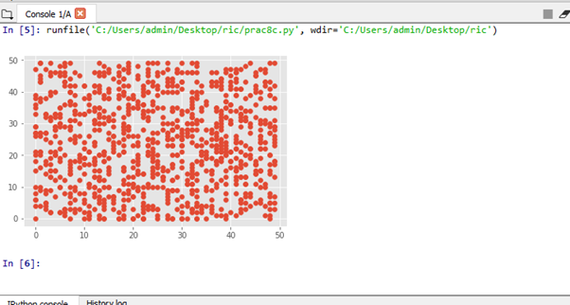

**Conclusion:** we have successfully computed no/weak correlation.

# **Practical 9**

## **A.Write a program to Perform linear regression for prediction.**

**Code:**

> #Perform linear regression

> m<-c(1,2,3,4,5,6)

> t<-c(25,22,30,34,45,52)

> #Label the chart

> png(file="Linear Regression")

> plot(t,m,col="red",main="Months and Temperature",abline(lm(m~t)),cex=1.6,pch=10,xlab="Months",ylab="Temperature")

> dev.off()

null device

1

> plot(t,m,col="red",main="Months and Temperature",abline(lm(m~t)),cex=1.6,pch=10,xlab="Months",ylab="Temperature")

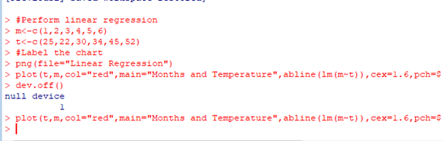

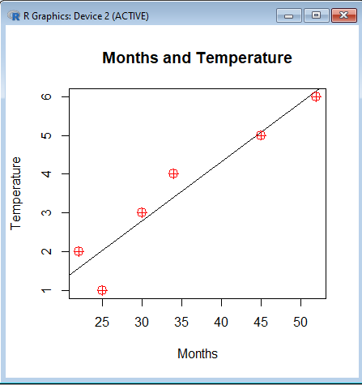

**Conclusion:** we have successfully performed linear regression for predicted.

## **B.Polynomial Regression.**

**Code:**

> #Polynomial Regression

> set.seed(16)

> x<-0:50

> y<-2.3-15.1*x+1.2*x^2+rnorm(length(x),20,50)

> plot(x,y)

> fit <- lm(y ~ 1 + x + I(x^2))

> points(x, predict(fit), type="l")

> summary(fit)

**Output:**

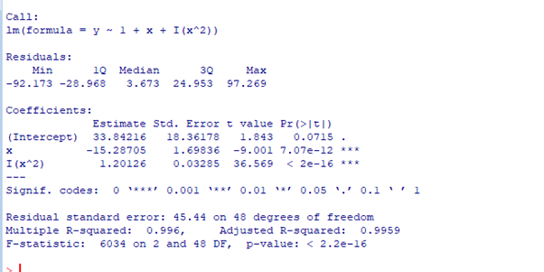

**Conclusion:** we have successfully performed polynomial regression in R.

# **Practical 10**

## **A.Multiple linear regression.**

**Code:**

> #Multiple linear regression

>ip<-mtcars[,c("mpg","disp","hp")]

> print(head(ip))

> m<-lm(mpg~disp+hp,data=ip)

> print(m)

> a<-coef(m)

>Xdisp<-coef(m)[1]

> print(Xdisp)

>Xhp<-coef(m)[2]

> print(Xhp)

**Output:**

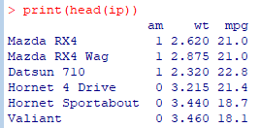

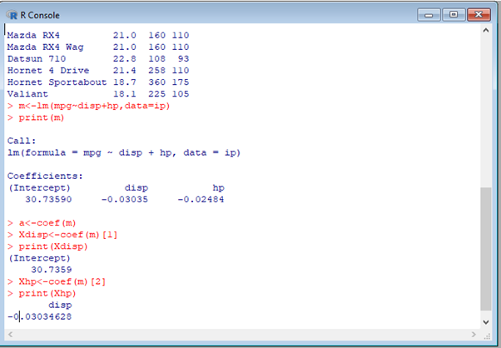

**Conclusion:** we have successfully performed multiple linear regression.

## **B.Logistic Regression.**

**Code:**

> #Logistic regression

>ip<-mtcars[,c("am","wt","mpg")]

> print(head(ip))

>am.data<-glm(formula=am~wt+mpg,data=ip,family=binomial)

> summary(am.data)

**Output:**

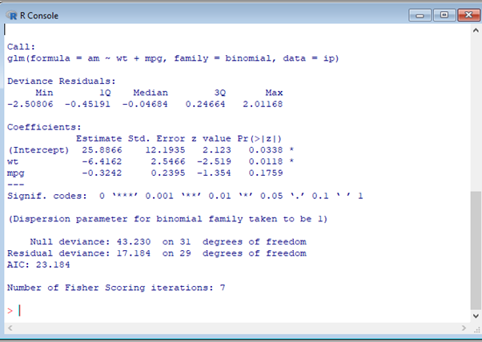

**Conclusion:** we have successfully performed logistic regression.